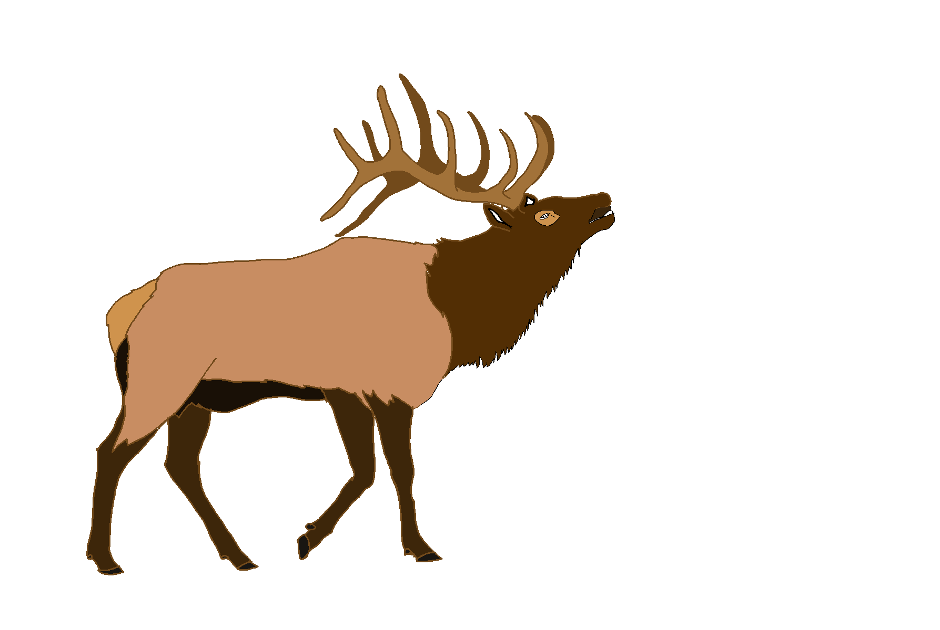

**Elk River City Council Meeting Agenda**

**Wednesday, October 2, 2024 – 5:00 p.m.**

**Andrew Bloom Community Center, 112 South Second Street, Elk River, Idaho**

1. Call to order
2. Pledge of Allegiance
3. Approve minutes: September 4, 2024 meeting and September 10, 2024 special meeting ***ACTION ITEM***
4. Financial Report ***ACTION ITEM***
5. Pay bills ***ACTION ITEM***
6. Visitors/Guests
7. Reports
8. Clerk
9. Public Works
10. Mayor
11. Council
12. Fire Department
13. Clearwater Highway District
14. Clearwater Ambulance

**Council Business Items**

1. Wastewater Facilities Project update
2. Approve final closeout report for Community Development Block Grant (CDBG) funds ***ACTION ITEM***
3. Set Public Hearing date for 2nd Community Development Block Grant (CDBG) application ***ACTION ITEM***
4. Approve PERSI enrollment for eligible employees ***ACTION ITEM***
5. Review City Ordinance 102c: Zoning
6. Residents solid waste fee possible update
7. Elk River communication issue possible update

**Adjourn**

How to call in for City Council Meeting

Phone: 1-888-278-0296

Participant code: 9086265