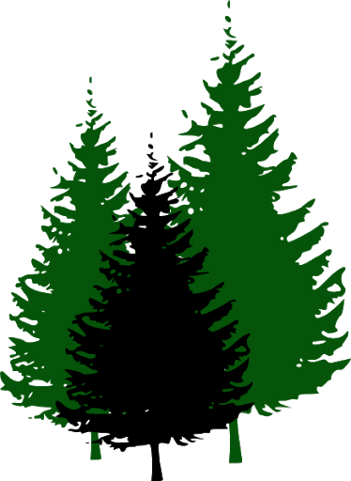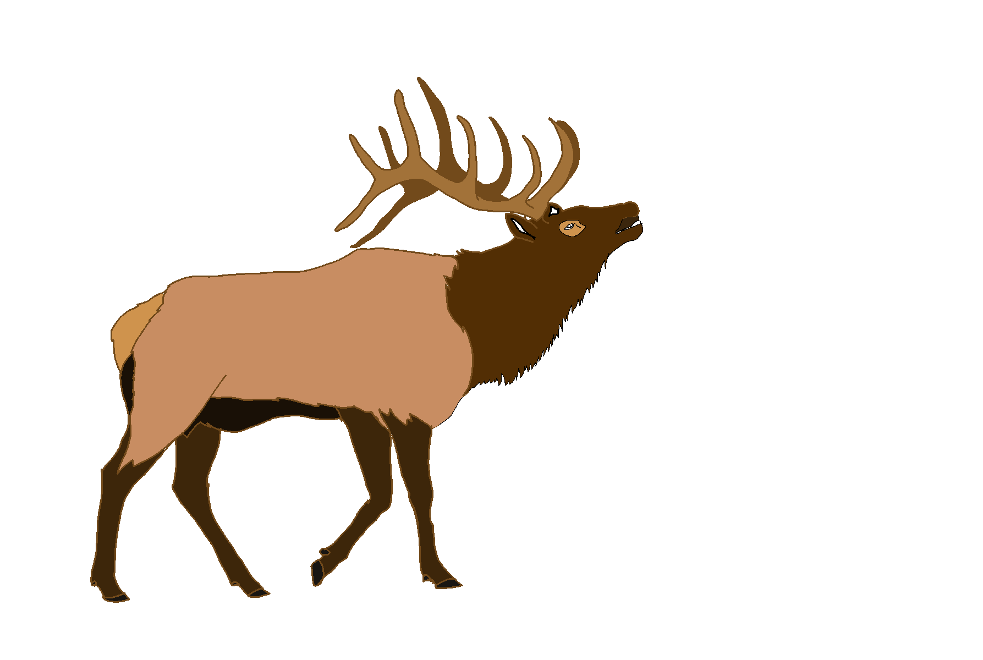 Elk River City Council Workshop Agenda
Thursday, January 4, 2024 – 11:00 a.m.
Andrew Bloom Community Center, 112 South Second Street, Elk River, Idaho

Agenda
- Call to order
- Proposed Elk River Camper Ordinance discussion
Adjourn

