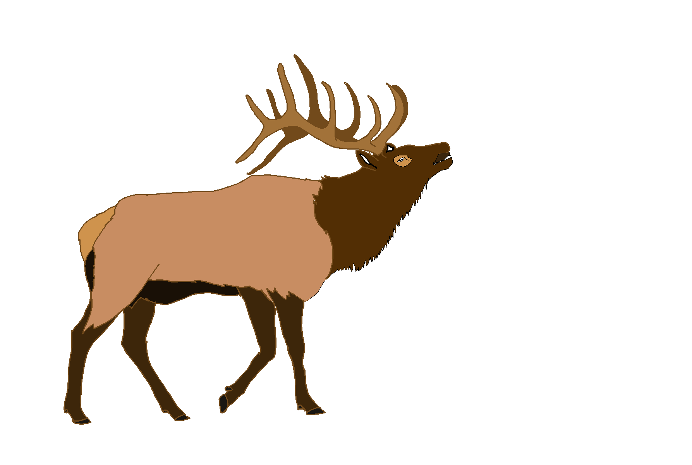 Campers in Elk River Committee Agenda
Wednesday Thursday, June 21, 2023 – 5:00 p.m.
206 North Front Street, Elk River, Idaho

- Call to order
- Visitors/Guests
- Campers discussion continued
Adjourn

*If you plan on attending please call Diana Olson ahead of time if possible at (208)826-3628. Thank you!

Corrected 6/19/23 CB

