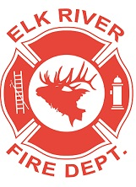
Elk River Fire Department Building Committee
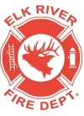
Wednesday, July 14, 2022
11:00 a.m.
Elk River Fire Hall, 106 South 4th Street, Elk River, Idaho

AGENDA
- Call to order
- Pledge of Allegiance
- Visitors
Business Items
- Flag pole install assistance
- Generator cover: supplies needed, who will build it ACTION ITEM
- Inland Cellular security system quote ACTION ITEM
- Outside spigot update
- Set date for grand opening ACTION ITEM

Adjourn

