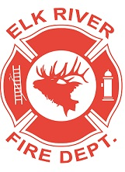
Elk River Fire Department Building Committee
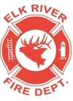
Wednesday, June 1, 2022
11:00 a.m.
Andrew Bloom Community Center, 112 South 2nd Street, Elk River, Idaho

AGENDA
- Call to order
- Pledge of Allegiance
- Visitors
Business Items
4. Status update
5. Outside spigot Possible ACTION ITEM

Adjourn

