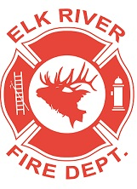
Elk River Fire Department Building Committee
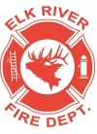
Wednesday, September 1, 2021
11:00 a.m.
Andrew Bloom Community Center, 112 South 2nd Street, Elk River, Idaho

AGENDA
- Call to order
- Pledge of Allegiance
- Visitors
Business Items
4. Approval to spend more than budgeted on exhaust system ACTION ITEM
5. Project items updates
6. Round table

Adjourn

