To whom it may concern;
Elk River Volunteer Fire Department  PO Box G  Elk River, ID 83827  Tel 208-826-3200  https://www.facebook.com/ElkRiverVolunteerFireDepartment/  elkriverfiredepartment@gmail.com | 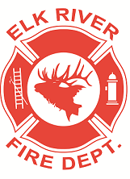

After seven years, the Elk River Volunteer Fire Department is close to meeting its goal of finishing our new fire hall. We will be holding a fundraising auction on September 11, 2021. We are looking for entities and businesses that are willing to donate merchandise or gift cards/certificates to auction off, either during the silent or live auction that day. Thank you for your support in this great cause.

All amounts raised during this fundraiser will go towards our new fire hall for the Elk River FD. We have started building the new fire hall but need funds to finish it in 2021.
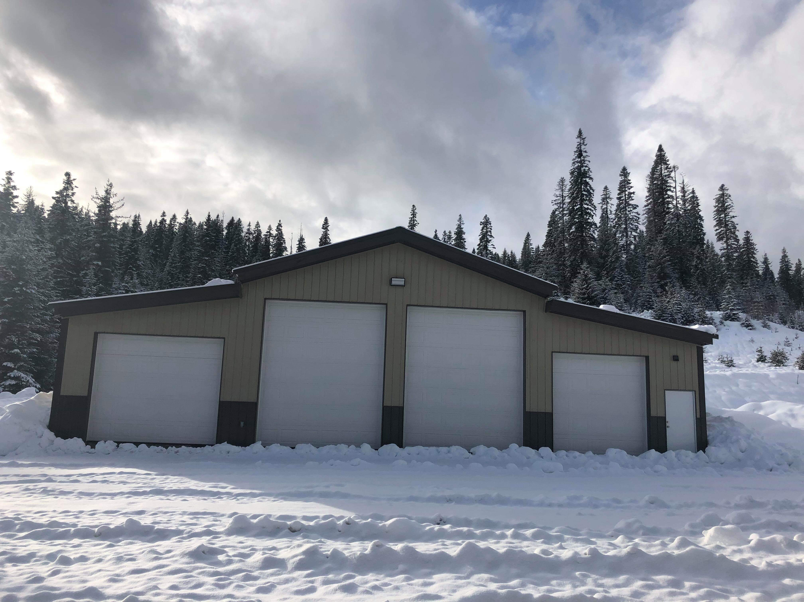

We would appreciate any donation, whether tangible or monetary to go towards this effort.
If we could have all donations in hand by Monday, August 30,2021 that would be appreciated.
You can contact the following individuals to coordinate delivery/pickup of the donation:
Kami Nibler (208) 826-3301, DeEtta Mitchell (208) 669-2476, Leesa Semler (509) 336-9780. Thank you!

Elk River Volunteer Fire Department staff
Donation Receipt
Cause: Elk River Volunteer Fire Department Auction
Date: September 11, 2021

Item Donated: ___________________________________________________________________________

Item Value: _______________________________________________________________________________

Received by: ______________________________________________________________________________

Date: ______________________________________________________________________________________

