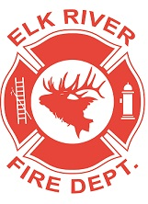
Elk River Fire Department Building Committee
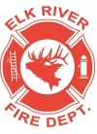
Wednesday, November 11, 2020
11:00 a.m.
Andrew Bloom Community Center, 112 South 2nd Street, Elk River, Idaho

AGENDA
- Call to order
- Pledge of Allegiance
- Visitors
New Business
4. Lumber prices – possible delay of building rooms ACTION ITEM
5. Insignia lettering ACTION ITEM
6. Round table

Adjourn

