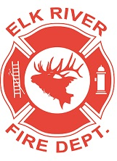
Elk River Fire Department Building Committee
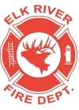
Wednesday, September 2, 2020
11:00 a.m.
Andrew Bloom Community Center, 112 South 2nd Street, Elk River, Idaho

AGENDA
- Call to order
- Pledge of Allegiance
- Visitors
New Business
4. Gravel purchase ACTION ITEM
5. Move furniture and generator
6. Kilz and paint for walls and rafters
7. Status on building rooms and plumbing finish and purchase of lumber/drywall, etc
8. Purchase of fridge, range, sinks, toilet, shower supplies and water heater ACTION ITEM
9. Discuss remaining items: siren, flag pole, turn out lockers, hydrant and signage
10. Round table

Adjourn

