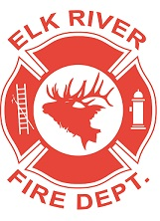
Elk River Fire Department Building Committee
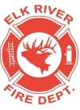
Monday, June 15, 2020
10:00 a.m.
Andrew Bloom Community Center, 112 South 2nd Street, Elk River, Idaho

AGENDA
- Call to order
- Pledge of Allegiance
- Visitors
New Business
4. Concrete Bid ACTION ITEM
5. Drain line repair
6. Water/sewer dig
7. Winter damage
8. Roundtable
Adjourn

