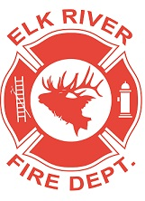 **Elk River Fire Department Building Committee**

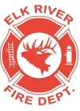**Wednesday, March 11, 2020**

**11:00 a.m.**

**Andrew Bloom Community Center, 112 South 2nd Street, Elk River, Idaho**

**AGENDA**

1. Call to order
2. Pledge of Allegiance
3. Visitors

4. Gravel update

5. Plumbing update

6. Future dig work ***ACTION ITEM***

7. Concrete bid status

8. Current fund status

9. Roundtable discussion

**Adjourn**