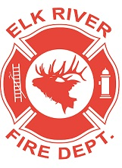
Elk River Fire Department Building Committee
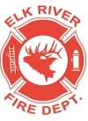
Wednesday, February 12, 2020
11:00 a.m.
Andrew Bloom Community Center, 112 South 2nd Street, Elk River, Idaho

AGENDA
- Call to order
- Pledge of Allegiance
- Visitors
New Business
4. Heater warranty ACTION ITEM
5. Round table discussion
Adjourn

