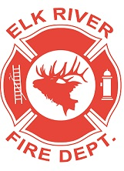
Elk River Fire Department Building Committee
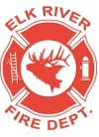
Wednesday, November 20, 2019
11:00 a.m.
Andrew Bloom Community Center, 112 South 2nd Street, Elk River, Idaho

AGENDA
- Call to order
- Pledge of Allegiance
- Visitors
New Business
4. Repairs to the building ACTION ITEM
5. Gravel update
6. Grant update
Adjourn

