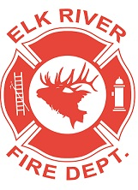
Elk River Fire Department Building Committee
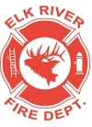
Wednesday, October 16, 2019
11:00 a.m.
112 South 2nd Street, Elk River, Idaho

AGENDA
- Call to order
- Pledge of Allegiance
- Visitors
Old Business
- Update on project status
- Update on grant applications
Adjourn

