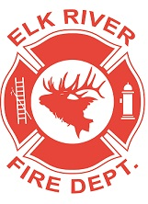
Elk River Fire Department Building Committee
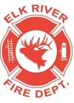
Tuesday, September 17, 2019
12:00 p.m.
112 South 2nd Street, Elk River, Idaho

AGENDA
- Call to order
- Pledge of Allegiance
- Visitors
Business Items - Possible Action Items
- Layout
- Water
- Sewer
- Heating
- Electrical
- Plumbing
- Propane
- Concrete
- Gravel
- List of remaining “To Do’s”
- Possible grant funding

Adjourn

