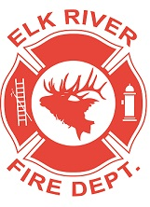
Elk River Fire Department Building Committee
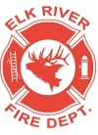
Wednesday, October 2, 2019
11:00 a.m.
112 South 2nd Street, Elk River, Idaho

AGENDA
- Call to order
- Pledge of Allegiance
- Visitors
New Business
- Review electrical bids - Action Item
- Go over “To Do” list - Action Item
- Review budget and prioritize work items - Action Item
- Update from Mayor on electrical dig
Old Business
- Layout
- Water
- Sewer
- Plumbing
- Propane
- Concrete
- Gravel
- Possible grant funding

Adjourn

